Mushroom Kingdom Meltdown
By Jeremy Thomas, Ryan Sweeny
Intro:
Join Toad, King Goomba or King Koopa in a 3 way battle of survival. Face enemies on both sides with their own strengths and weakness. Pick a side and battle it out in this 3 way strategy game. Mushroom Kingdom Meltdown relies more on tactics than brute force. Grab all your lives and head for the battle field.
Rough plot:
As Mario and Luigi leave for vacation to Yoshi’s Island, King Koopa (also known as Bowser) makes a pact with King Goomba in an attempt to kidnap Princess Toadstool (Peach). As the battle plans unfold Bowser decides that his agreement will see some “unexpected” causalities if he lets someone else lead the fight. Bowser then decides as the troops start flowing out that if they aren’t a koopa they are fair game. As the troops move out two toadstool scouts spot the rampaging horde of Goomba/koopa troops. One of these scouts runs back to relay this new discovery to Toad and Princess Peach. After the relay Toad gives the order to gather up their defenses and prepare for battle. As the second scout arrives back to the castle he brings good new with him. His new information is that the koopa troops have been spotted slaying their own allies the Goombas, which is a relief to Toad. On the other hand, King Goomba also gets this information and with notice of Bowsers new plans King Goomba also gives the same order and a two way fight becomes a three way brawl.

Character bio:
- Koopa Force (Bonus: +Attack)
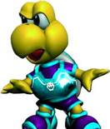
  - Koopa Troopa
    - Range of Movement:3 spaces
    - Attack: 2
    - Defense:1
  - Hammer Brothers
    - Range: 2 spaces
    - Attack: 5
    - Defense: 2
  - Dry Bones
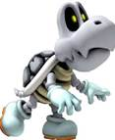
    - Range: 2
    - Attack: 1
    - Defense:5
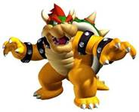
  - Bowser (King)
    - Range: 1
    - Attack:8
    - Defense:6
- Toad Force (Bonus: +Defense)
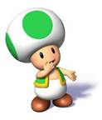
  - Green Toad
    - Range:3
    - Attack:2
    - Defense:1
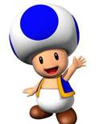
  - Blue Toad
    - Range: 2
    - Attack: 5
    - Defense: 2
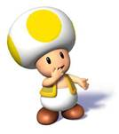
  - Yellow Toad
    - Range: 2
    - Attack: 1
    - Defense: 5
  - Toad (King)
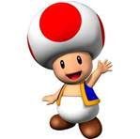
    - Range: 1
    - Attack: 8
    - Defense: 6

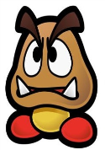
- Goomba Force(Bonus: +Speed)
  - Grounded Goomba
    - Range: 3
    - Attack: 2
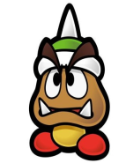
    - Defense: 1
  - Helmet Goomba
    - Range: 2
    - Attack: 5
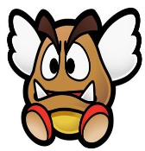
    - Defense: 2
  - Winged Goomba
    - Range: 2
    - Attack: 1
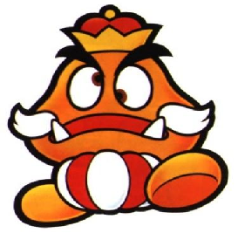
    - Defense: 5
  - King Goomba(King)
    - Range: 1
    - Attack: 8
    - Defense: 6

Gameplay:
In the beginning of the game the players choose their armies. Each character has a set of attributes (Attack, Health, and Range). The character’s Range determines how many spaces it can move as well as its attacking range (i.e. if a character’s Range is 3, it can attack enemy characters that are 3 or less spaces away). The character’s Attack determines how much damage it does when it attacks another character. When a character is attacked, that character’s Health is subtracted by the Attack of the attacking character (i.e. if a character of Attack 3 attacks a character with Health 5, the attacked character’s Health is now 2). The health of each character is kept track with the “Scorecard” (Figure 2) each team has. One health-piece in a character’s column equals one Health point, and they are taken away when a character loses Health. Each army has an attribute bonus when they are in their respective areas of the game board. For Toads, if they are attacked while they are in their area, they lose one less Health point than they normally would. Goombas gain a +1 to their Range, and Koopa’s gain a +1 to their Attack.
The characters start in the center-most space of their area, designated by a lighter shade of that area’s color (see Figure 1). The first turn goes to the Koopa army. The four characters may start in any combination of the four start spaces. At the beginning of each player’s turn they have the option to move, attack, or pass with each character (ie. Each character will only do ONE of the following per turn: move, attack, or pass). A pass is whenever a character neither moves nor attacks. The player can choose to move/attack/pass with their characters in any order they wish, as long as each character only is used once per turn. Because the game spaces are triangles, a character can only move between spaces whose sides are adjacent to its current space, and NOT spaces that have adjacent corners. If a player chooses, they may attack the same enemy characters multiple times, so long as each attacking character has not moved/attacked yet this turn, and is in range. Whenever a character loses all of its Health, it “dies” and is removed from play. Once a player loses their King, the player loses and all remaining characters are removed from play. A player’s turn is over when all of its pieces have either moved, attacked, or been passed. The order of player rotation is Koopa -> Goomba -> Toad. The game is won when only one King remains.
Art Breakdown:
Refer to attached concept art.
Art Assets:
- Cardboard for the game board
- Red paint
- Yellow paint
- Blue paint
- Green paint
- Dark red paint
- Dark green paint
- Dark blue paint
- 12 plastic character pieces, in the shape of their respective character
- 42 Cardboard health pieces (simply just cardboard circles)
- Three cardstock scorecards
- Cardboard box to house the game
Text Assets:
- One instruction manual, so people can learn how to play the game

Figure 1
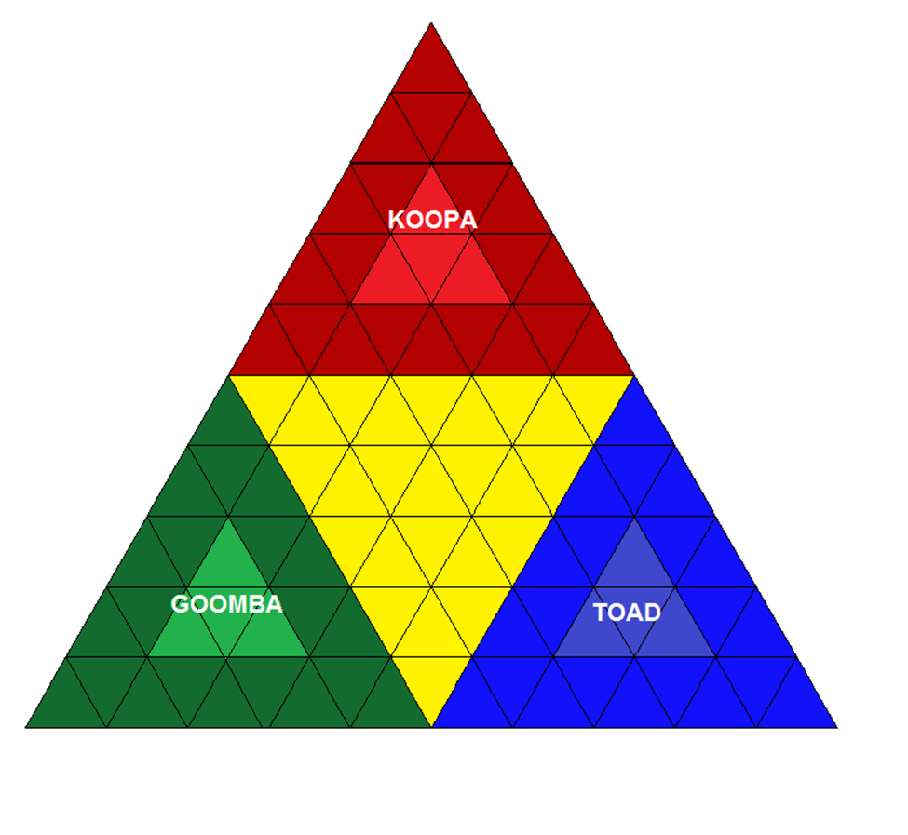

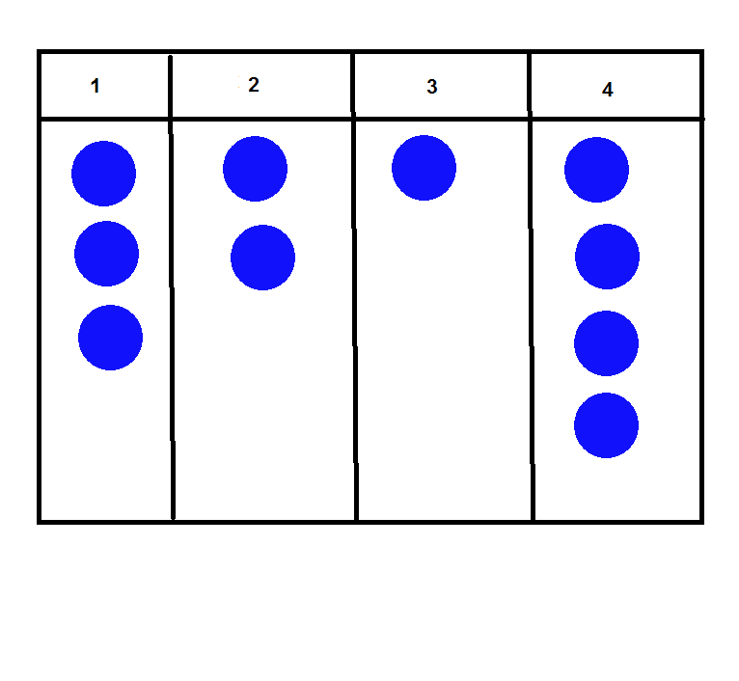

Figure 2

